**Orthopter abundance**

* Orth ~ Phen + (1|Tower) : More orth when phonologic stage includes flowers and seeds.
* Orth ~ period + (1|Tower): more orth during periods c and d
* Orth ~ Phen + period + (1|Tower) : probable correlation between time of the year and phenological stage of plants.

Wild yields more tax groups: Ant, Dip and Orth. No harvest is important to presence of Ants.

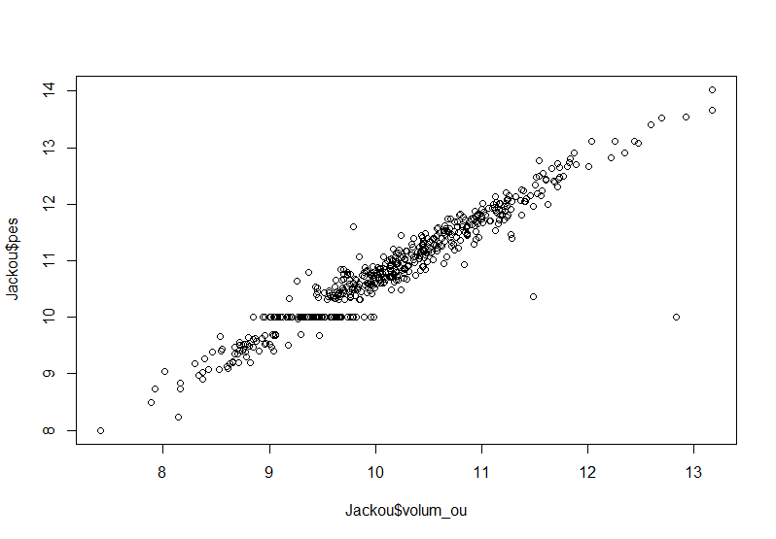**Egg weight relation to volume**

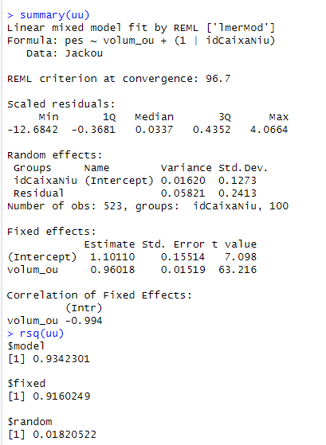

Hi ha variació entre postes?

* Pes ou com a resposta – mida com a predictor. Random niu-torre + id estructura.
* 21% variació a nivel de Caixa niu
* Afegir torre com a random.
* Data de posta (fixed) – does condition depend on date?

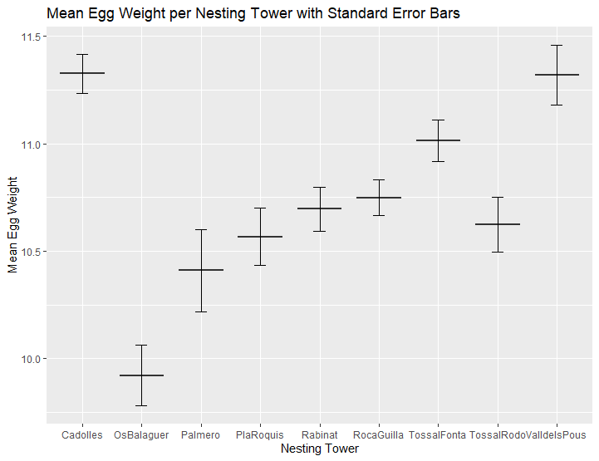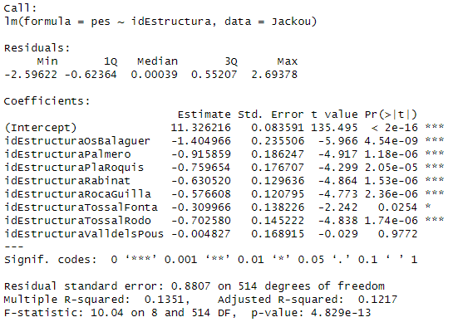Cadolles has heavier eggs than the rest of towers, but ValldelsPous

Egg volume decreases with laying order in the majority of nests; however, it is just a trend of -0.11. This is probably due to some nests having opposite trends.

* Pes varia segons sincronia de posta? Does volume vary depending on sinchrony?
* Does volume vary between towers?

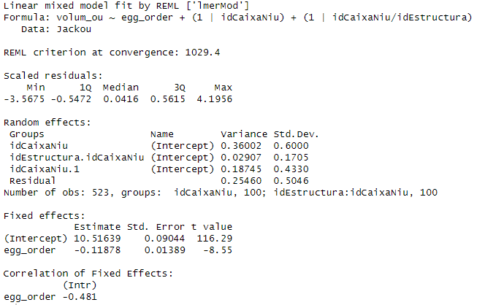

* how to codify nested random effects correctly?
* <https://www.muscardinus.be/statistics/nested.html>
* Validar si data de posta afecta. Quality of parents, laying date, distribution of nutrients/proteins/water per egg (depending on order)

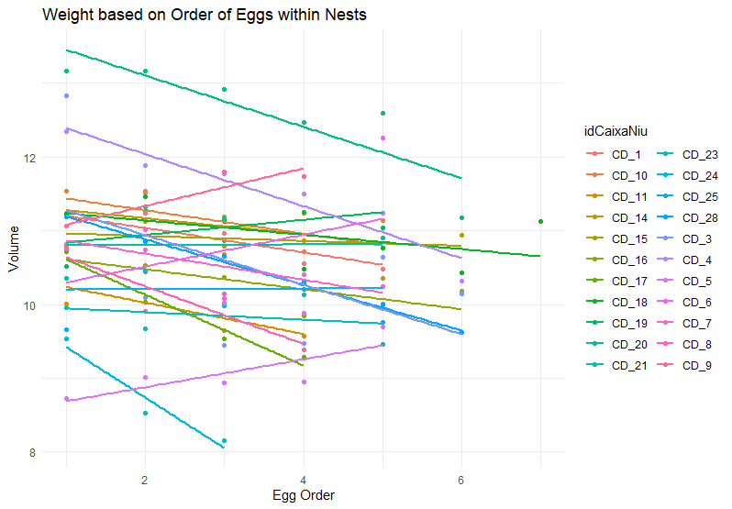

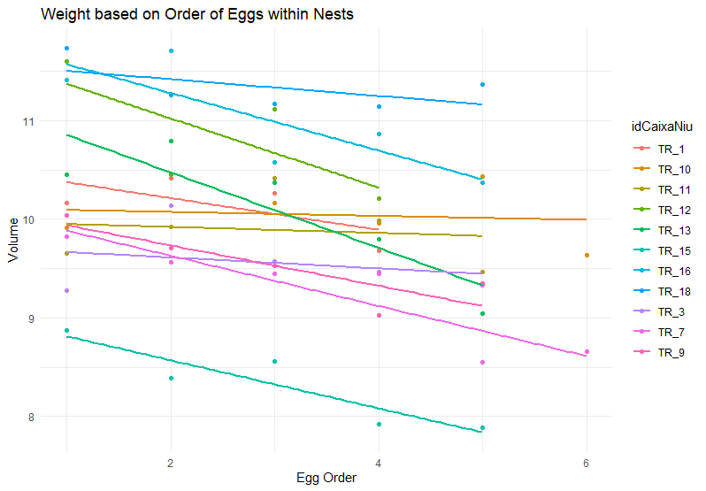

Clutch size has no effect on egg weight

Chicks’ growth appears to increase most between 7 and 14 days, being the first hatchling the heaviest throughout its growth.

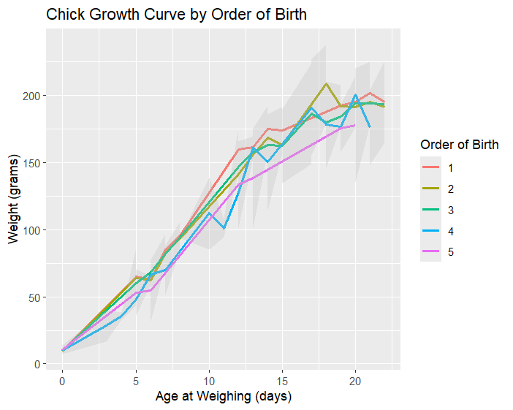

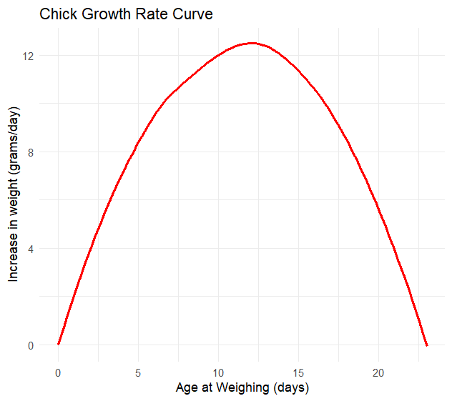

DRAMA